**1. Write a JavaScript In changes the value of the src (source) attribute of an image.**

**Code:**

<!DOCTYPE html>

<html>

<head><title>moj</title></head>

<body>

<h2>Change Img </h2>

<p>In this case JavaScript changes the value of the src (source) attribute of an image.</p>

<img id="myImage" src="sad.png" onmouseover="changetosmile()" onmouseout="changetosad()" style=" width:100px">

<script type="text/javascript">

function changetosmile()

{

document.getElementById('myImage').src='smiling.png'

}

function changetosad()

{

document.getElementById('my Image').src='sad.png'

}

</script>

</body>

</html>

**Output:**

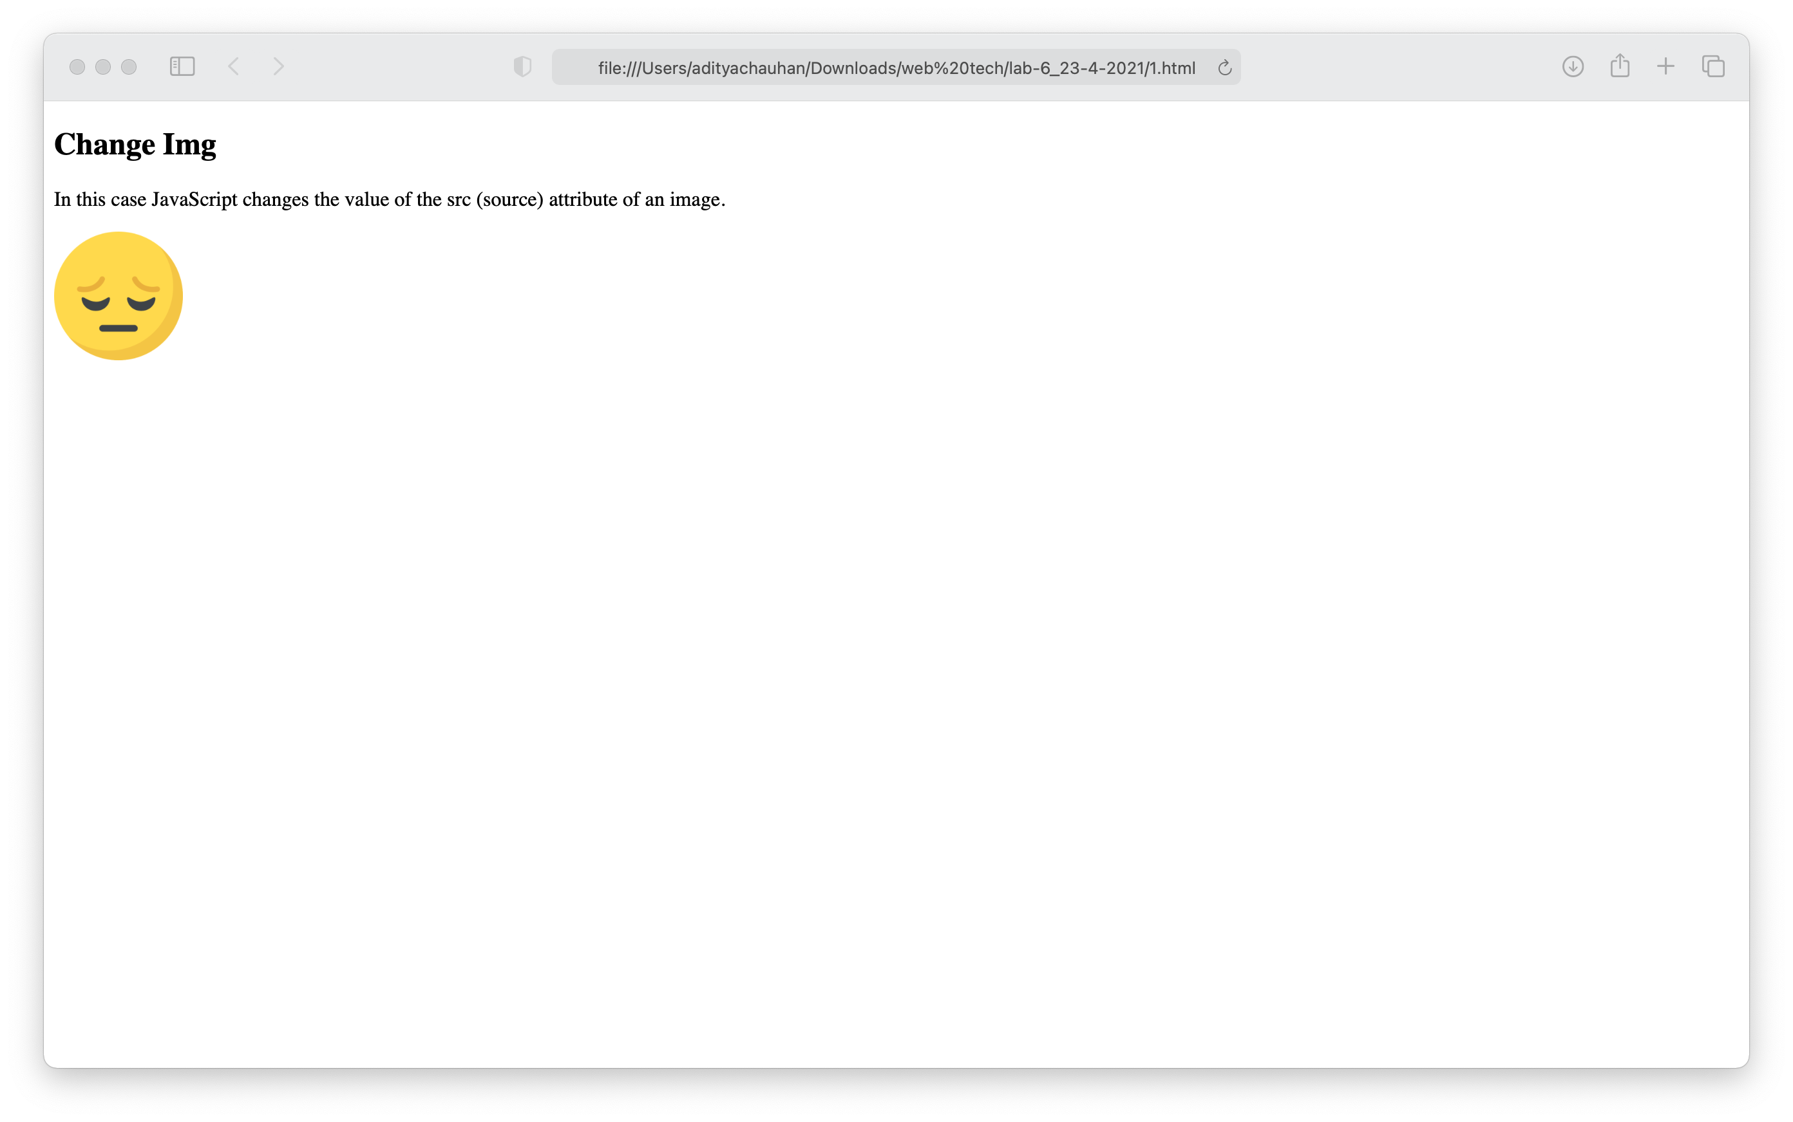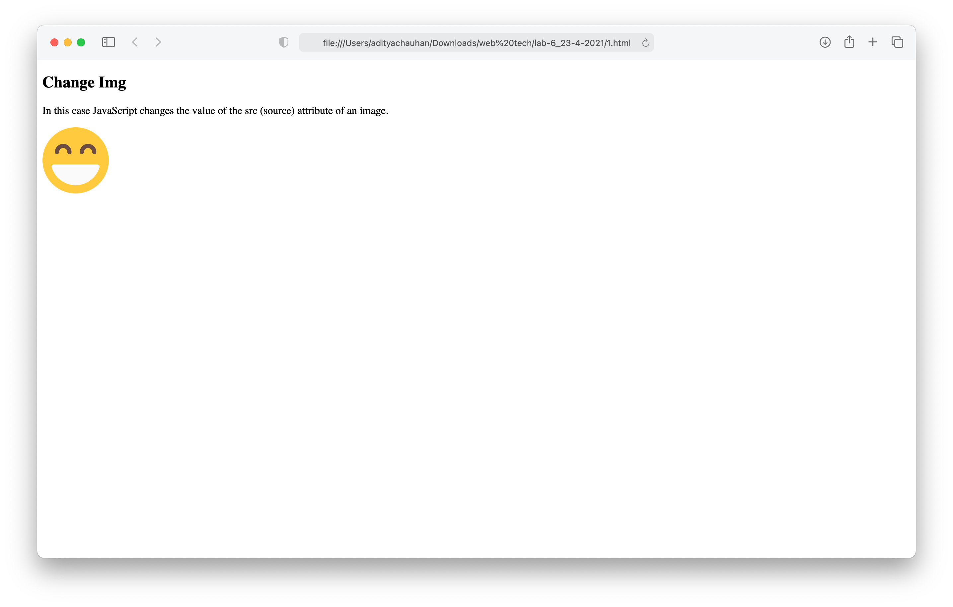

**2. WAP to change the background color according to user clicks on different button.**

**Code:**

<!DOCTYPE html>

<html> <head>

</head>

<body>

<form action="welcome.html" onsubmit="return validateForm()" > Phone number: <input type="number" name="no" placeholder="enter the contact number">

<input type="submit" Ivalue="Submit">

</form>

</body>

</html>

<script>

function validateForm() {

var x = document.getElementsByName("no")[0].value; if (x.length!=10) {

alert("Enter valid number");

return false;

}

}

</script>

**Output:**

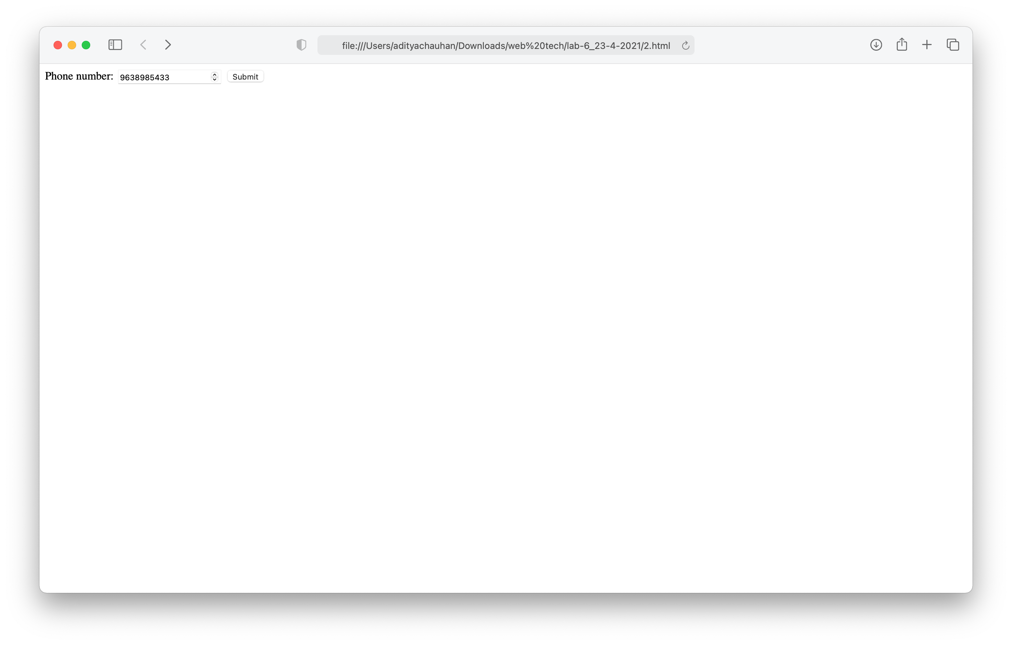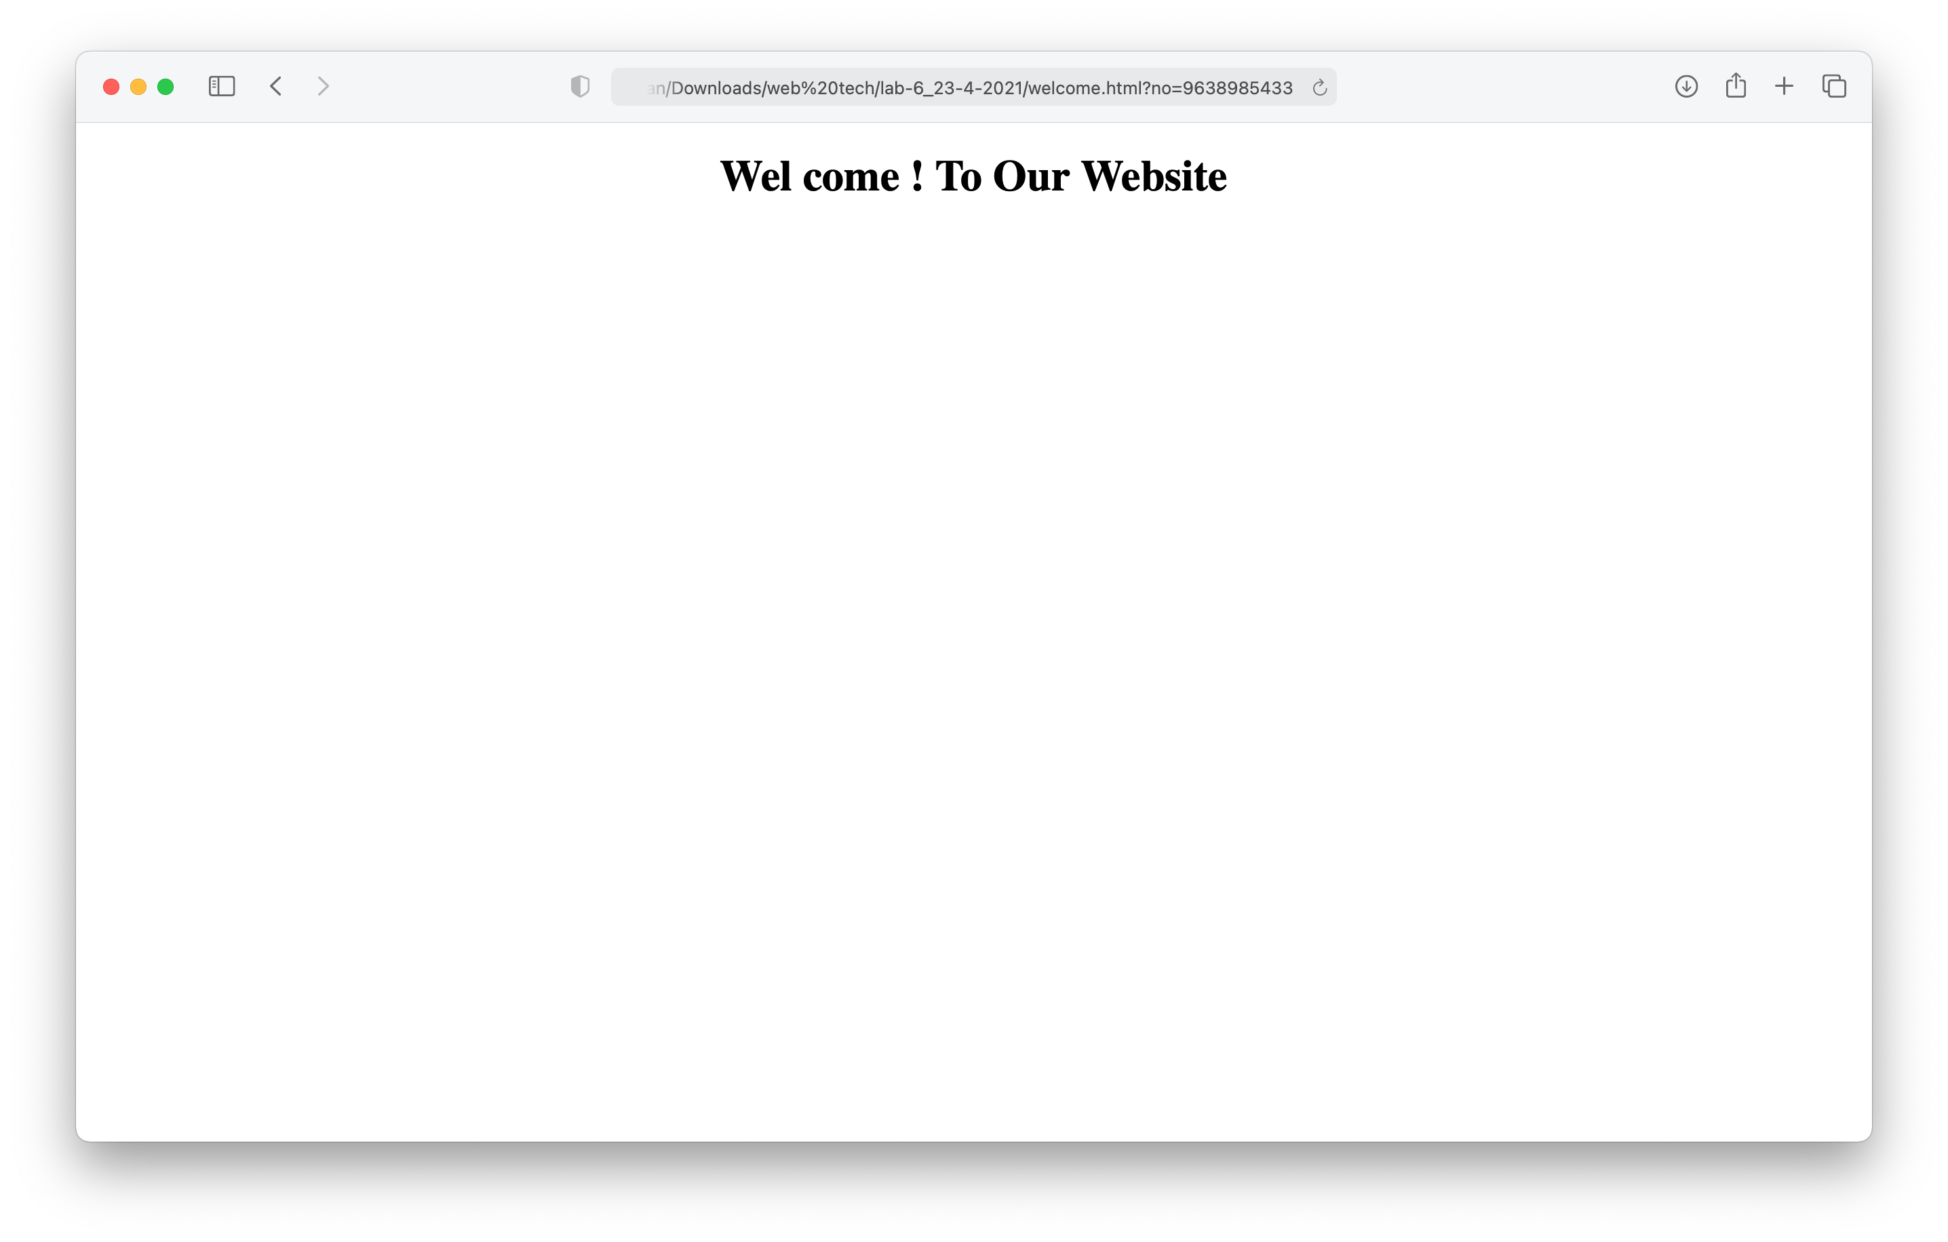

**3**. **WAP to show the first name and last name value which user has entered in the text box using alert box using javascript.**

**Code:**

<!DOCTYPE html>

<html>

<body>

<h1 id="demo"></h1>

<table border="1">

<th colspan="2">Account information</th>

<tr>

<th>Name</th>

<td></td>

<tr>

<th>Balance</th>

<td></td>

</tr>

<tr>

<th> Account number</th>

<td></td>

</table>

<script>

var data = '{"udata":["aditya",123456,20124051]}';

var sync=JSON.parse(data);

var x= document.getElementsByTagName("td");

for (var i=0;i<=x.length; i++) {

x[i].innerHTML=sync.udata[i];

}

</script>

</body>

</html>

**Output:**

